How to convert the Deal Tracker to a PDF

Open Deal Tracker
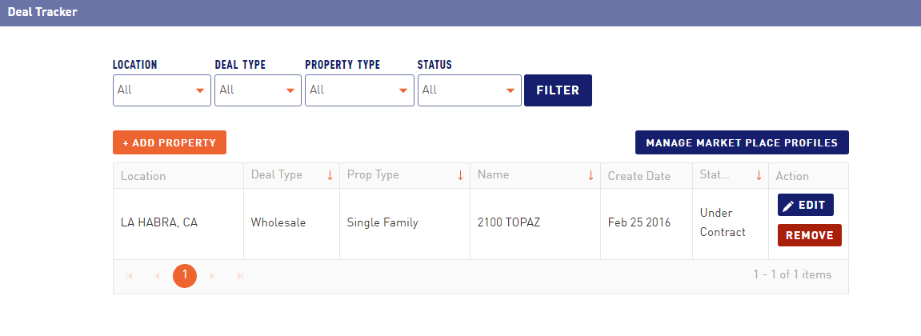

Open the specific property
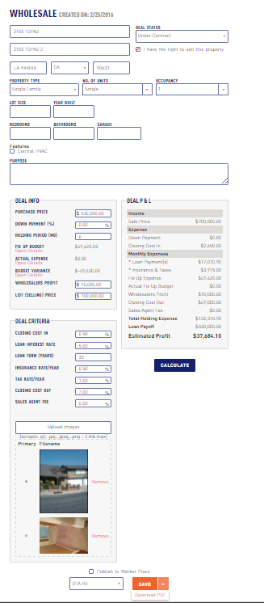
Click on the dropdown box and hit download PDF

