Reference Notes

(Real Estate)

How to Create a Market Place Profile

Log into MyOTA

Click on your name in the upper right-hand corner:

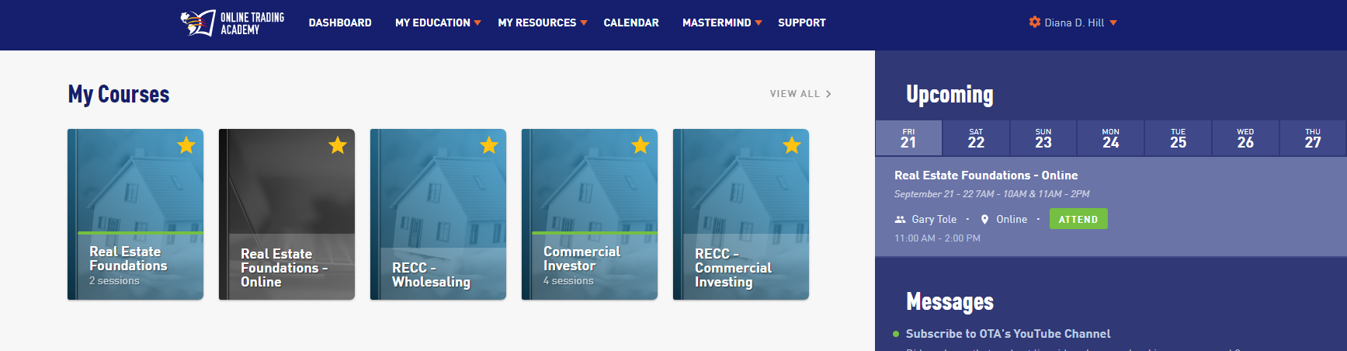

Open the dropdown box:

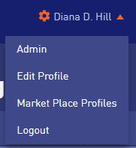

Click on Market Place Profiles:

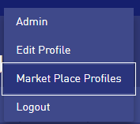

Now complete your profile and save

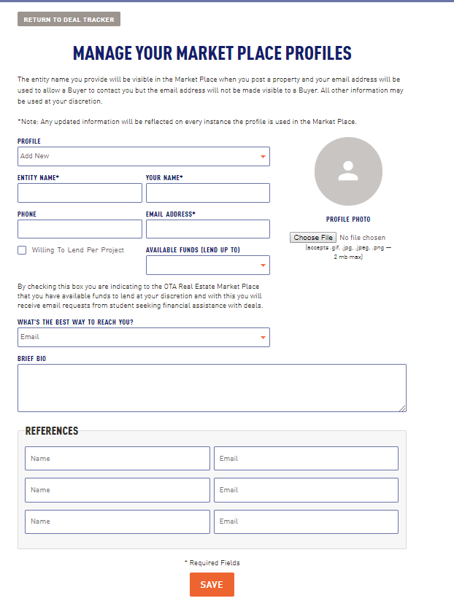

Page 2 of 2
© Online Trading Academy Franchise Corporation 2016 - CONFIDENTIAL

